How to compile Orion source files?



LinkBirdTech

https://codecanyon.net/user/linkbirdtech

**Download and install Visual Studio, if you don't have the version.**

Download Microsoft Visual Studio 2013

<https://visualstudio.microsoft.com/vs/older-downloads/>

**Download and install Crystal Report for Visual Studio, if you don't have the version. Please follow**

**Step-1**

Please download Crystal Report Version 13.0.12

<http://downloads.businessobjects.com/akdlm/cr4vs2010/CRforVS_13_0_12.exe>

**How to compile Orion source files**

**Requirement:**

* Microsoft Visual Studio 2013 target Framework="4.5"
* Crystal Report 13.0.12

**Step-1**

* Start Microsoft Visual Studio 2013
* Click **File** menu & Click **Open Project …** Open Project window will appear
* Locate **Orion** solution file (*.sln) & click **Open** button.

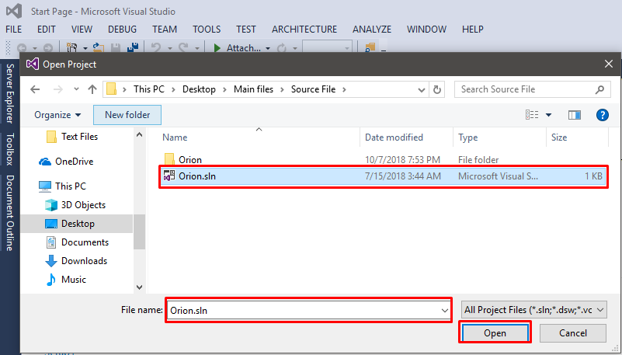

Click on Start button.

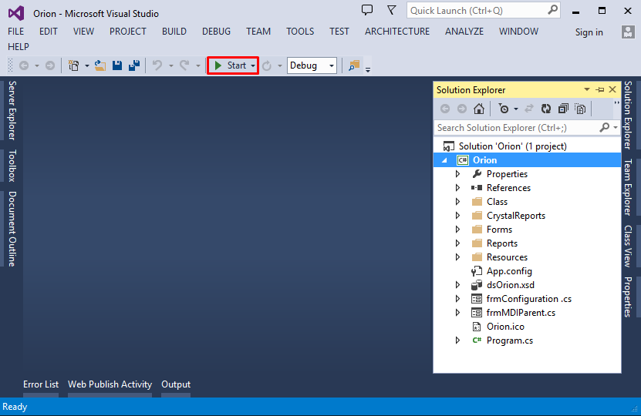

Enter your connection string into Orion Connection manager form. Click OK Button. A successful message dialog will be displayed then Start Orion again.

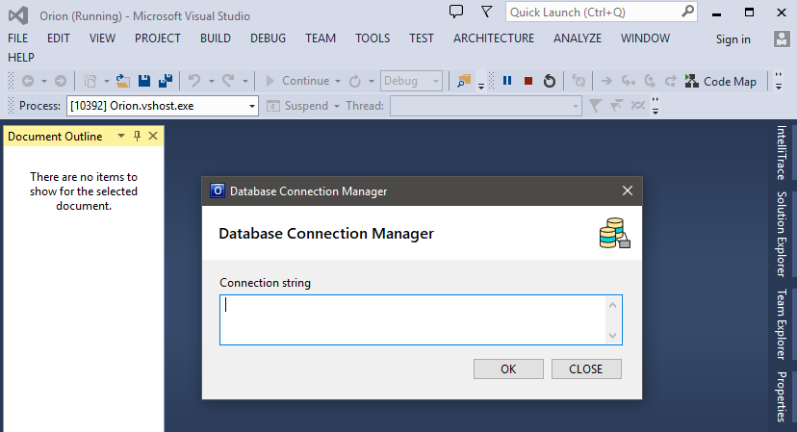

**How to switch SQLite to Microsoft SQL Server**

1. Open clsUtility.cs file from Orion solution explorer
2. Remove all code of clsUtility.cs at Orion solution explorer.
3. Open clsUtility.cs using notepad from **Main files\Class\SQL Server folder**. And copy all code.
4. Now paste all code of the Orion solution explorer into clsUtility.cs
5. Build and Run

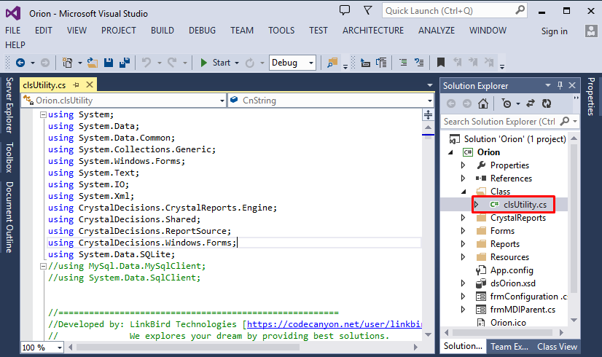

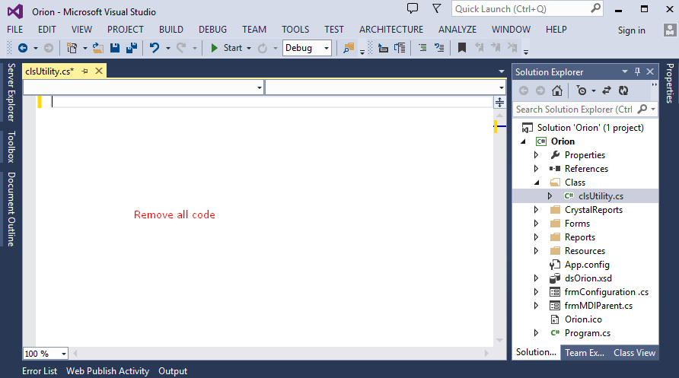

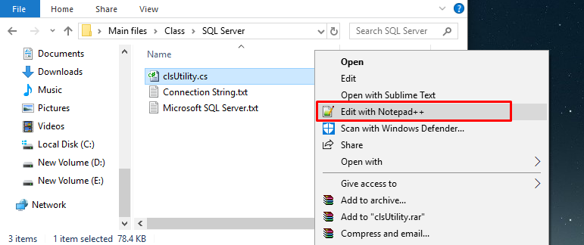

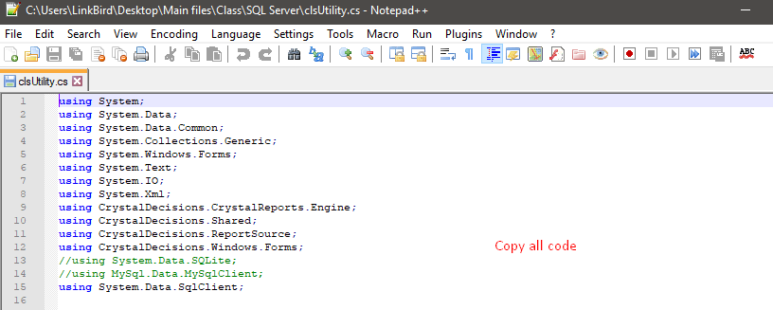

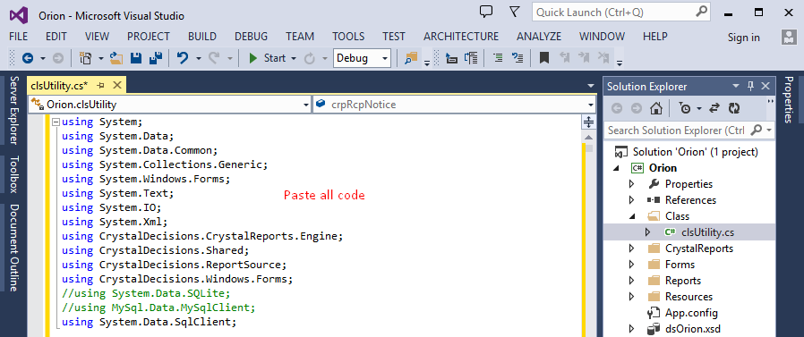

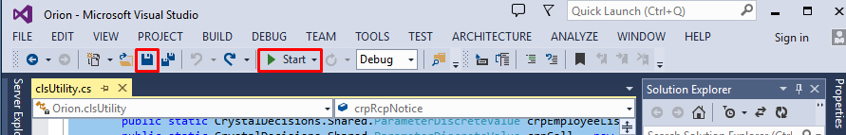

**How to switch SQLite to MySQL**

1. Open clsUtility.cs file from Orion solution explorer
2. Remove all code of clsUtility.cs at Orion solution explorer.
3. Open clsUtility.cs using notepad from **Main files\Class\** **MySQL folder**. And copy all code.
4. Now paste all code of the Orion solution explorer into clsUtility.cs
5. Build and Run